|  |  |  |  |  |  |
| --- | --- | --- | --- | --- | --- |
|  |  |  |  |  |  |
|  |  |  |  |  |  |
| |  | | --- | |  | |  |  |  |  |  |
|  |  |  |  |  |  |
|  |  |  |  |  |  |
| **2000 BPH LINE PROJECT**  **Presentation to LAJTHIZA** | | | | |  |
|  |  |  |  |  |  |
|  |  |  |  |  |  |
|  |  |  |  |  |  |
|  |  |  |  |  |  |
|  |  |  |  |  |  |
|  |  |  |  |  |  |
|  |  |  |  |  |  |
|  |  |  |  |  |  |
|  |  |  |  |  |  |
|  |  |  |  |  |  |
|  |  |  |  |  |  |
|  |  |  |  |  |  |
|  |  |  |  |  |  |
| Presented by BMI 4R Co,Ltd. | | | | |  |
| Date: 2018-01-11  　 Ref No.BMI2000DO-01 | | | | |
|  |  | . | |  |
|  | |  | | --- | |  | |  |  |  |  |
|  |  |  |  |  |  |
|  |  |  |  |  |  |
|  |  |  |  |  |  |
|  |  |  |  |  |  |

|  |  |  |  |  |  |  |
| --- | --- | --- | --- | --- | --- | --- |
|  |  |  |  |  |  |  |
|  |  | **Contents** |  |  |  |  |
|  |  |  |  |  |  |  |

**1 .The configuration and designing principle**

**2.** **The technical description**

**3.** **The hygienic level**

**4.** **User-friend and safety principle**

**5. Energy conservation and environment protection**

**6.** **Specification of the main machine:**

**7.** **Technical description of individual machine**

**8.** **Preparing jobs from the customer’s side.**

**9. Equipments and price list**

**10.** **General Business Term**

**11. Contact details**

**12. Lay out ( attached CAD File)**

**1: The configuration and designing principle**

1.1: The designed production capacity: 2000 BPH (Bottle per hour)

1.2: The rinsing filling and capping bottle: 5-gallon (18.9Liter) PC bottle.

1.3: The detergent rinsing time for the outer washer machine: ≥10 seconds

1.4 The high pressure (70 Bar) rinsing time: 10 second, and 10 cycles

1.5: The detergent rinsing time for the inner washer machine: ≥52 seconds

1.6: The disinfectant rinsing time for the inner washer machine: ≥52seconds

1.7: Ozone water rinsing time: 0-26 seconds (adjustable)

1.8: Filling time: ≤15S

1.9: Filling volume accuracy: ±50ml

1.10: Outer washer machine rinsing pressure: ≥0.30MPa

1.11: Inner washer machine rinsing pressure: ≥0.3MPa-0.8MPa

1.12: Rinsing stages quantity for inner washer:

High pressure washing: 01 stages;

Detergent rinsing: 04 stages;

Disinfectant rinsing: 04 stages;

Reused water rinsing: 01 stages;

Ozone water rinsing: 02 stages;

Drip: 05 rows

1.13: Bottle quantity for each rinsing stage: 10pcs

1.14: Filling nozzles: 08pcs (multi rows filling)

**2. The technical description**

2.1: The unique detergent rinsing technology has been used to the inner washer machine, by using the special up and down reciprocating rinsing system to make sure the thoroughly cleaning to the bottles. At the same time, the special nozzles can spray the pressure water to each corner of the bottles to process completely rinsing.

2.2: The filling machine adapts the linear non-touch filling technology, by using the inverter/two flux filling e to control the quantity of water, the water filling level can be controlled within ±150ml when the filling time is 15 second.

2.3: By using the laser to process the hole opening for the whole system,

2.4: Special Reciprocating rinsing system is used for the detergent washing part ,the rinsing nozzles will insert into the bottles and process the repeat rinsing. Three parts washing technology to cleaning the bottles with the special nozzles for each part.

2.5: The automatic water replenishing system is equipped to each rinsing tanks when the water level is low. *(Remarks: the water source and the pump is provided by the buyer)*

2.6: Each row of rinsing nozzles is equipped with one individual GRUNDFOS pump (Note: except the drip stages), no bottle, no rinsing. And this can avoid the neutralization of the detergent and the disinfectant at the time of starting or stopping the machine.

2.7: The rinsing tanks and the pipeline which contact with the chemicals are all using stainless steel 316L ( Note: The chemical dosing tank for the automatic chemical dosing system is PE material)

2.8: Famous brand parts are used to the machine , such as Airtac cylinder , GRUNDFOS pump , Danfoss inverter, Siemens PLC, Schneider or ABB electrical components .etc .

2.9: Each rinsing stages equips the diaphragm type pressure meter to monitor the rinsing pressure.

**3: The hygienic level**

3.1: All the pipeline is designed and built as per the USA NSF standard

3.2: All the T type pipe line use the tee or using the pulling and welding technology, no dead angle.

3.3: All the tank use the round corner head cover, food grade standard.

3.4: No dead angle and special structure water distribution pipe for filling, not only meets the hygiene standard requirements but also can guarantee the same pressure for each filling valve.

3.5: No dead angle hygiene grade residual water collecting tray to make sure there is no residual water.

3.6: No leaking and no residual water designing can guarantee the floor is clean and no residual water, this will avoid the accrue of the bacteria.

3.7: The CIP interface is equipped to the filing pipe.

3.8: The machine with the adjust foot can above the floor 150mm, for the easy cleaning to the floor .

3.9: All the pressure meters are using the diaphragm meter and connected by clamp

3.11 Centralized drainage system. Waste water of whole production line is collected and delivered to centralized drainage system of inner washer and discharged. Easy operation, simple drainage system of factory

**4.User-friend and safety principle**

4.1: User-friend designing for the easy operation and maintenance .

4.2: All the corner adopt the round corner to avoid the hurt to the operator

4.3: Disconnecting switches can be equipped to system for the motor and pump to avoid the wrong operation. Remarks: the disconnecting switches are optional items

4.4: Enough space inside the inner washer, each for cleaning.

4.5: The machine to the floor is the more than 150MM, each for cleaning and maintaining .

4.6: Two types of filter (drawer-type and precision net filter )is equipped to prevent the solid materials to enter into the tank and the pump, guarantee clear passage in pipe, avoid blockage at nozzle jammed.

4.7: warning signs for the moving parts to remind the operator.

4.8: Locking system is equipped for the control box high voltage (220V or above)

4.9: Clamp type connecting for the rinsing pipe and the water distribution pipe for each disassembling and cleaning.

4.10: The crossing-conveyor ladder can be equipped as required ( note : Optional item )

4.11: Automatic production line , with automatic online detecting device , such as overload protecting , bottle jam alarming, water level alarming. .

**5.Energy conservation and environment protection**

5.1: Make full use of the reused water which after the ozone water rinsing stage, recycling use of the water to save the water.

5.2: The detergent tank consists of three layers. The middle layer is made of heat protection material, effectively reduce the energy consumption.

5.3: Liquid quick flow device, detergent liquid quickly flows back detergent tank, reduce heat emanation.

5.4: Drip stage after the detergent and disinfectant stage to avoid the loss of the chemicals and reduce of the concentration.

5.5: The ozone water rinsing flow is adjustable

5.6: No overflow water after filling by using the inverter and our unique filling technology.

5.7: All the rinsing pumps are equipped with the inverter.

**6: Specification of the main machine:**

6.1: Outer washer: Side plate: 3mm, water collecting tray: 2mm.

6.2: Inner washer: Side plate: 4mm, water collecting tray: 2mm. The main structure pipe: 80 mm *80mm* 3.0mm

6.3: Filler: Side plate: 3mm, water collecting tray: 2mm.

6.4: Water tank: head cover: 3mm, tank Wall: 2.5mm, The inner layer of the detergent tank and the disinfectant tank: SS 316L.

**7.Technical description of individual machine**

|  |  |
| --- | --- |
| **7.1.De-capper** |  |

|  |  |  |  |
| --- | --- | --- | --- |
| **Model** | **Capacity(BPH)** | **Heads** | **Dimension(L*W*H)(MM)** |
| **BG-4** | 2000 | 4 | 1550*1220*2150 |

**Definition**

To remove the cap from the recycled bottles, the whole process is full-automatic,

**Configuration**

Sensor: CARLO

Pneumatic components: AIRTAC

Motor and gear box: SITI

The metal frame of the whole line is made by stainless steel SUS304

**Features**

● Adjustable clamping intensity of decapper clamp, just properly to remove cap, no scratch to bottle mouth.

● Adjustable height of decapper clamp, ensure high accuracy of cap removing.

● Mechanical arm to put the removed caps to the container orderly.

●Movable decapper head. After removing cap, decaper heads move on to the top of cap collection bin, and then loosen cap, and then return original location. Avoid cap dropping everywhere.

● Automatic detecting system detects bottle amount. Working synchronously with other equipments. No bottle enter, no decapping.

● Convenience for adjusting, maintenance and replacing.

**Photos**

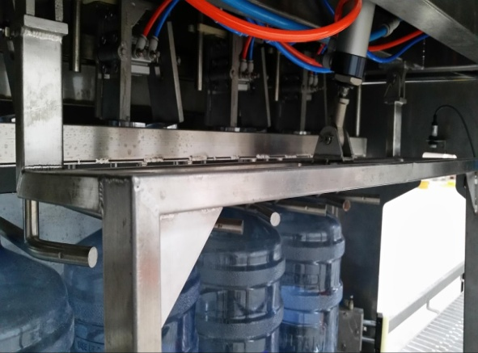 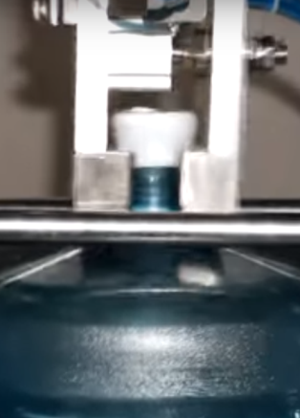

Video Link

<https://www.youtube.com/watch?v=3OzWw8klcHg>

|  |  |
| --- | --- |
| **7.2.Outer washer** |  |

|  |  |  |  |
| --- | --- | --- | --- |
| **Model** | **Capacity(BPH)** | **Type** | **Dimension(L*W*H)(MM)** |
| **WXR-2000** | 2000 | Liner | 4000*940*1900 |

**Definition**

Outer washer is the device which rinse bottle surface, use high-pressure and reused water to rinse, then use hot detergent liquid to brush the bottle by bottle-shape brushes, after that rinse again the bottle by reused water.

**Configuration**

●The main frame of the machine is made by stainless steel 304 .

●The detergent tank is made by stainless steel 316L.

●Sensor: Carlo

●Rinsing pump: GRUNDFOS

●Pneumatic components: AIRTAC brand

●Motor and gear box: SITI, Italy brand

●Electronic components: Schneider or ABB

**Features**

● Bottle shape brushes are used to clean the bottles surface, include the bottle neck and bottom position.

● One set inverter was equipped to adjust the capacity,

● Pipes are connected with sanitary clamps. Easy to disassemble and clean.

● Centralized drainage system.

**Feature of detergent rinsing and tank**

● Detergent liquid is recycled according to its cleanness. Reduce running cost.

● Liquid quick flow device, detergent liquid quickly flow back detergent tank, reduce heat emanation.

● Stainless steel 316L detergent tank with round corner, not deal angle.

● Open design of detergent liquid application. A variety of detergent liquids are available to this chemical replenish system.

**Feature of reused water rinsing**

● The reused water can come from inner washer or tap water to reduce the running cost.

● Rinsing nozzles spurt reused water fanwise. Achieve good rinsing effect.

● Rinsing flux/pressure is adjustable. Strainer is equipped before the pump to prevent the big solid materials enters into the tank and the pump.

● working independently. Automatically detect bottles, and work/ temporary stop accordingly.

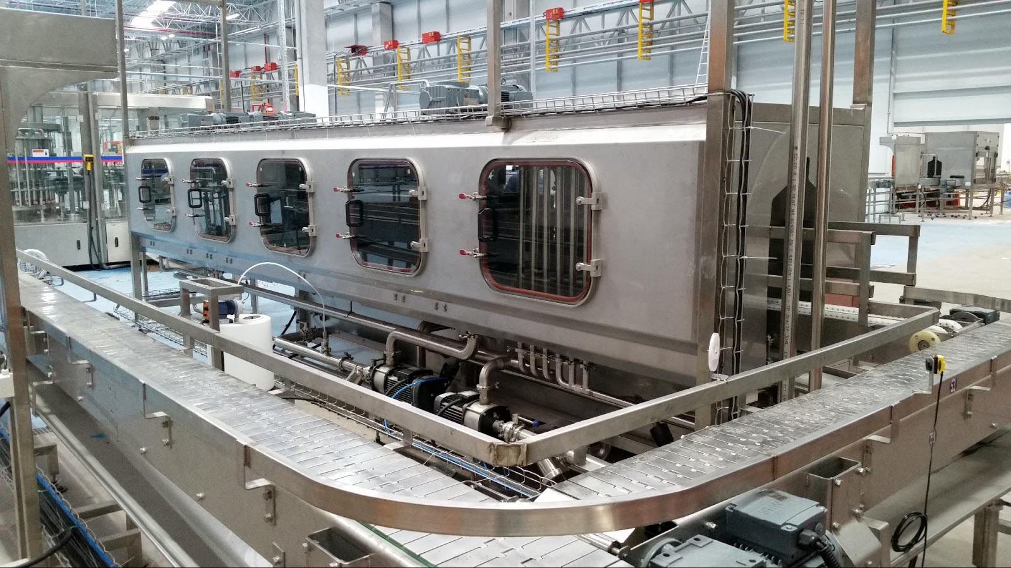

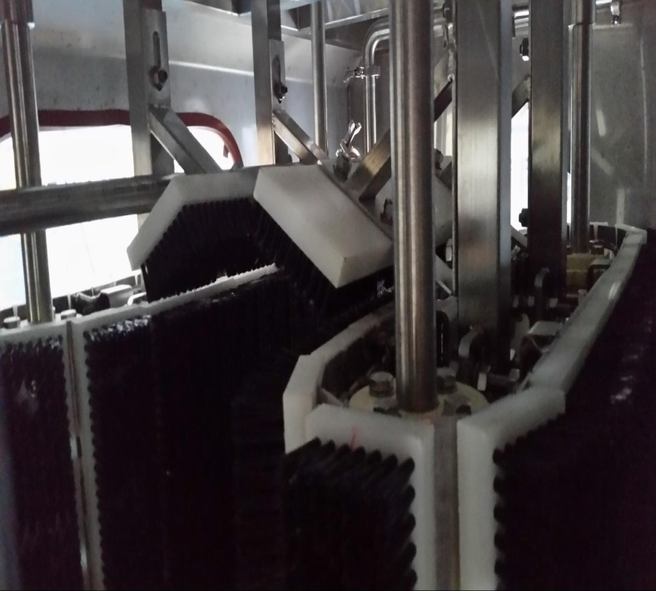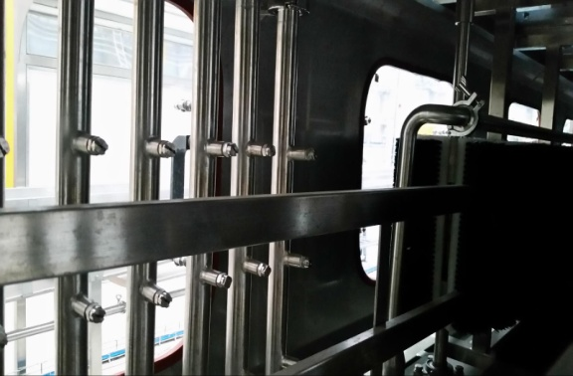

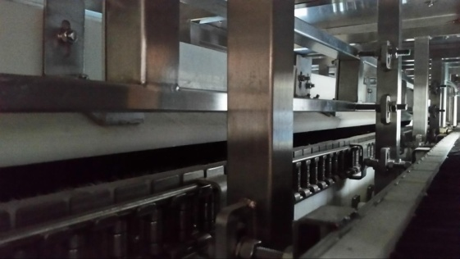

|  |  |
| --- | --- |
| **7.3.High pressure washer** |  |

|  |  |  |  |
| --- | --- | --- | --- |
| **Model** | **Capacity(BPH)** | **Heads** | **Dimension(L*W*H)(MM)** |
| **HP-2000** | 2000 | 10 | 5000*2150*2500 |

**Definition**

This Machine is designed to place the bottle by semi-manual bottles inside. And, automatically the bottles start rotating and nozzles up and down control by PLC after that PC bottle is placed to washing part. The nozzles are moved up and down in the bottle, and spray rinsing water at a high pressure of 70bar. Generally, PC bottle is easily contaminated with green algae and scale. And, also, sometime it’s contaminated with edible oil which is difficult to wash with existing washing machine. Our High Pressure Washing Machine can remove those of all contaminations up to 99.9%. It can be possible to wash the external of bottle as an option

**Configuration**

The metal frame of the whole device is made by stainless steel SUS304.

Sensor: CARLO

Pneumatic components: AIRTAC

Motor and gear box: SITI

Electronic components: SCHNEIDER

Pump: Made in Italy ( UDOR,INTERPUMP,CATS)

**Features**

# All stainless steel construction ( S.S. 304)by argon welding.

# Adjustable Nozzles up and down time and high pressure (70 bar above)

# Fully integrated control panel by PLC control panel

# Automatic bottle loading and unloading

# Automatic washing with high pressure perfectly

# Low water consumption washer design

# Washing technology to clean the bottles with the special nozzles for each part.

# Protective cover on running parts assures the operation safety.

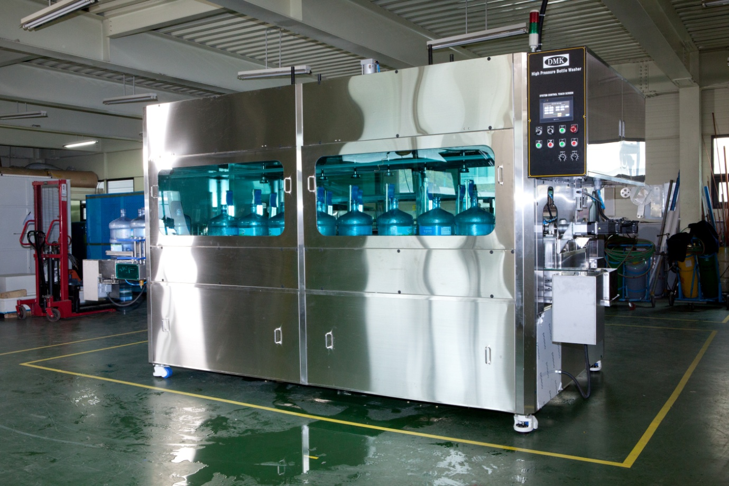

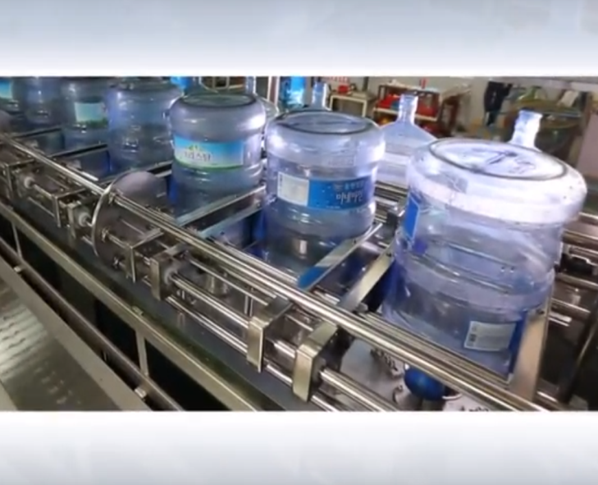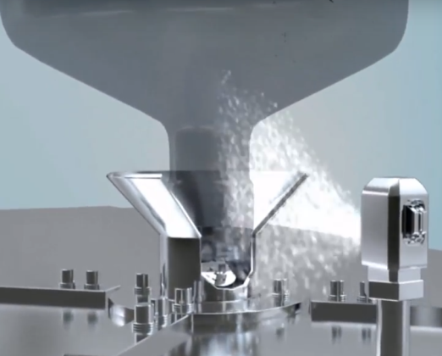

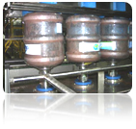 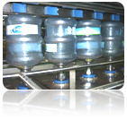

Video link

<https://www.youtube.com/watch?v=-MudtOAy9rQ>

|  |  |
| --- | --- |
| **7.4. Bottle feeder & un-loader and Inner washer** |  |

|  |  |  |  |
| --- | --- | --- | --- |
| **Model** | **Capacity(BPH)** | **Heads** | **Dimension(L*W*H)(MM)** |
| **NX-2000** | 2000 | 10 | 3217*8200*2500 |

**Definition**

Inner washer is to clean, sterilize the internal of 5 gallon bottles, which is a major equipment of 5 gallon filling line.

**A. Bottle feeder and un-loader parts**

Bottle feeder is to load bottles into inner washer from conveyor. It is built with inner washer. Its main design principle is loading bottle accurately, preventing contamination and damage from bottles and bottle un-loader is the device to take the bottles from the inner washer after bottles are washed and send to the filing position.

**Configuration for bottle loader & un-loader**

●The main frame of the machine is made by stainless steel 304 .

●Sensor: CARLO

●Pneumatic components: AIRTAC brand

**Features for bottle loader & un-loader**

●Side plate made of 2mm thickness stainless steel 304.

●Double axes bottle stopper cylinder. Guarantee accurate and stable actuation.

● Doors are equipped with high quality organic glass. Easy to monitor running status.

● Handle of door made of 8mm thickness stainless steel.

● Water chute shaped on bottom plate. Water drained quickly.

● Controlled by PLC. Working in the mode of cooperating with other equipments automatically. If inner washers stop running because of malfunction, or no bottle enter bottle feeder, it stops temporarily.

● High quality sensor, guarantee loading bottles of accurate amount each time. And stop bottle entering properly via bottle stopper cylinder, prevent bottle damaged by machine.

● Sufficient base space. Easy to tidy.

**Working steps for bottle loader & un-loader**

Bottles entering→ pushing bottles into hoppers→ hoppers rotary in 90 degree→ pushing bottle into inner washer→ hoppers return in place

5 steps loading guarantee loading bottles accurately, without bottle drop. It loads bottles with small strength, which prevents damage to bottle, and extends the lifetime of bottles.

**B. Inner washer**

**Configuration for Inner washer**

Cylinder: AIRTAC brand

Rinsing pump: GRUNDFOS

Motor and gear box: SITI, Italy brand

Water tank: stainless steel 316L for 3 layer detergent tanks, stainless steel 316L disinfectant tank, stainless steel 304 reused water tank.

The metal frame of the whole line is made by stainless steel 304

Electronic components:

PLC: Siemens, Inverter: Danfoss, Sensor: Carlo, Contactor: Schneider

**Features for Inner washer**

●Optimized inner washing process by adopting re-using the detergent liquid, disinfectant liquid, and ozone water to reduce the running cost.

●The chamber body of inner washer is made of 4mm stainless steel 304, assuring the strength

●10mm thickness tempered glass windows. Easily monitoring running status. 8 mm thickness stainless steel surround is equipped to protect glass. Easy open, strong and nice look.

●One inverter is equipped for the main shaft motor( for bottle holder chain)

●The detergent tank consists of three layers. Internal layer is made of stainless steel 316L while external layer is made of stainless steel 304, and middle layer is made of heat protection material. Effectively reduce energy consumption. The tank equipped the modular electrical heating system, liquid level detector, and temperature controller.

● Disinfectant tank made of stainless steel 316L to prevent the chemicals corrosion. Reused water tanks made of stainless steel 304.

● All tanks are equipped with automatic water replenish mechanism.

● All tanks adopt round seal head, no dead angle, manhole is equipped on the side of tank, which gives convenience for cleaning.

● Built-in overflow pipe of each tank. Automatically drain overflowed water.

● Each row of rinsing nozzles is equipped with one individual GRUNDFOS pump (Note: except the drip stages), no bottle, no rinsing

● Each pump is equipped with the diaphragm meter to monitor the rinsing pressure. By using the clamp connecting for easy disassembling.

● Optional Danfoss or LG inverter can be equipped to each pump, to accurately control rinsing pressure and reduce energy consumption.

● Two types of filter (drawer-type and precision net filter )is equipped to prevent the solid materials to enter into the tank and the pump, guarantee clear passage in pipe, avoid blockage at nozzle jammed. It has the advantage of low pressure drop, permanent filtration of the medium, simple handling/basket cleansing, and low-maintenance..

● Each precision net filter is equipped with two butterfly valves. It is to shut down pipe before clean the inside strainer.

● Multi temperature and pressure rinsing.

●Protective cover on running parts assures the operation safety.

● Blade type rinsing nozzles designing without any dead angle rinsing.

● Special up and down reciprocating rinsing system is used for the detergent washing part to make sure the thoroughly cleaning to the bottles.

●Three parts washing technology to cleaning the bottles with the special nozzles for each part.

● Round corner between bottom plate and side plate. No dead angle, reach sanitary level, easy to clean.

● Sanitary type residual collecting tray without any dead angle, bottom plate of chamber is tilting; allowing quick-flow of liquid, reducing the ponding, and avoiding contamination.

●2-layers washing pipe adopts food grade silicone wire hose with stainless steel cover, enhancing reliability. Clamp type connector ensures easily installing and dismantling.

● Both ends of the rinsing pipe can be easily removed for internal clean, all “T” shape pipes are pull-welding, which assure the hygiene grade

● With special bottle mouth cleaning and sterilizing device

● Built-in exhaust fan interface on the top to drain out the steam (the fan and outlet pipe is out of this proposal).

● Enough for the space from the bottom of the device to ground, easy to cleaning.

● Centralized drainage system. Waste water of whole production line is collected and delivered to centralized drainage system of inner washer and discharged. Easy operation, simple drainage system of factory.

● Optimized rinsing processes. Guarantee thoroughly clean and sterilize the internal of bottles. At the same time, reduce water consumption and chemical consumption.

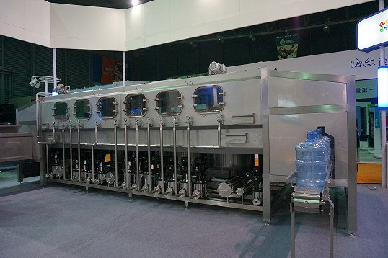

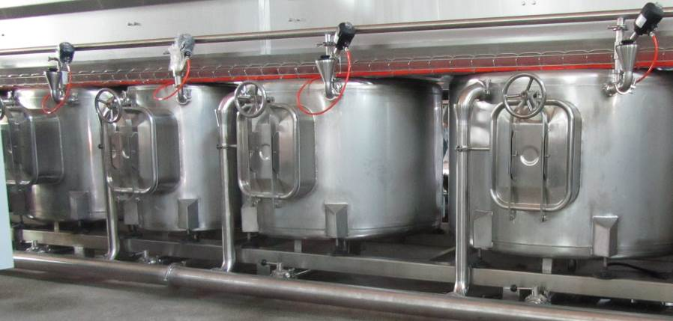

Video Link

<https://www.youtube.com/watch?v=RxQsATa0quI>

**Inner washer washing stages description:**

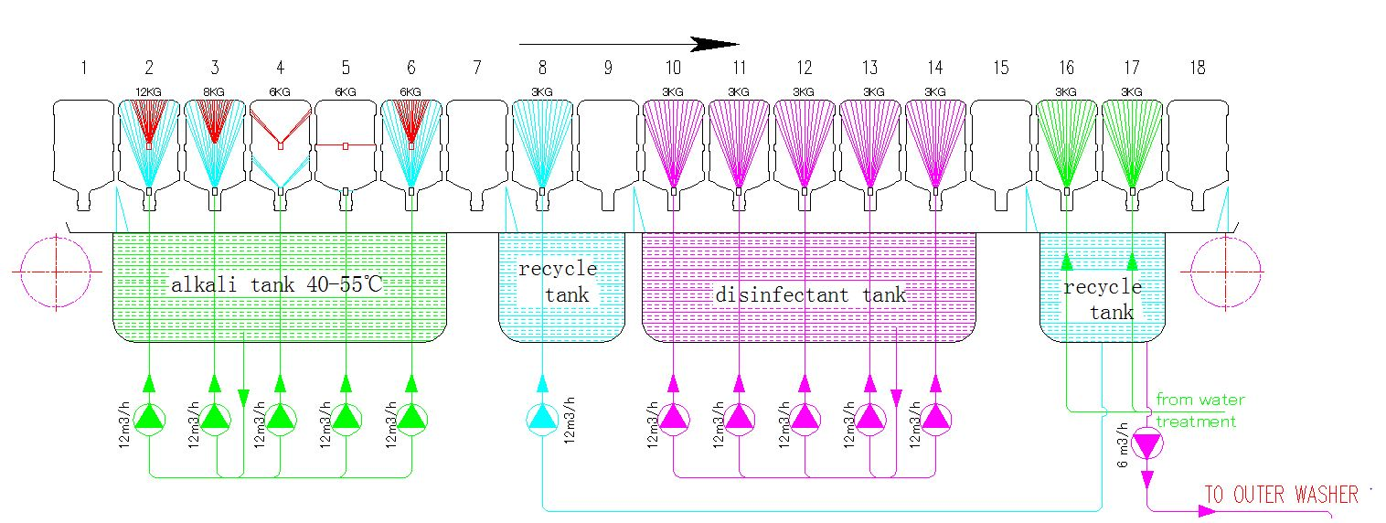

**1.Drip**

Give time to water that attaches on the bottle outer surface, which happens on outer washing machine, avoiding the water contaminating detergent (alkali solution) and decreasing concentration of alkali.

**2.Reused water**

The reused water is from the ozone water rinsing stage ,

Pressure:0.4MPa

By using the linear type rinsing nozzle to remove most of the particle and solid material which attach on the bottle inside wall. Nozzle testing flow : 1m3/h.

**3. Drip**

To drip the residual water and the foreign particle ,to avoid to reduce the detergent temperature and concentration.

**4,7 . Warm detergent rinsing**

Temperature: 45-55℃

Pressure:0.4MPa

By using the fixed nozzle to rinsing the bottom of the bottles

Nozzle testing flow : 1m3/h

**8,10. Hot detergent rinsing**

Temperature: 60-65℃

Pressure:0.6-0.8MPa

By using the annular nozzles to process the effective rinsing to the lower part of the bottles, two cycles

Nozzle testing flow : 1m3/h

**11.Drip**

To collect the residual detergent which attached on the bottle

**12.Reused water rinsing**

To clean the residual detergent which attach on the wall ,and avoid the neutralization with the following disinfectant rinsing

By using the fixed nozzle to rinsing the bottles

Nozzle testing flow : 1m3/h

**13 .Drip**

To drip the residual reused which attached on the bottle inner wall to avoid the neutralization with the following disinfectant rinsing.

**14.17Disinfectant**

Pressure:0.4MPa

By using the fixed nozzle to rinsing the bottles

Nozzle testing flow : 1m3/h

**18.Drip**

To collect the residual disinfectant which attached on the bottle inner wall . At the same time , the residual disinfectant liquid can sterilize the bottle

**19.20. Rinsing**

Ozone water rinsing

Pressure:0.4MPa

By using the fixed nozzle to rinsing the bottles

Nozzle testing flow : 1m3/h

The rinsing pump is from the water treatment system

**21.Drip**

To collect the residual water to the reused water tank

|  |  |
| --- | --- |
| **7.5.Liner filler (with inner washer)** |  |

|  |  |  |  |
| --- | --- | --- | --- |
| **Model** | **Capacity(BPH)** | **Heads** | **Dimension(L*W*H)(MM)** |
|  | 2000 | 10 | 3217*8200*2500 |

**Definition**

To fill product water into clean bottles. It is one of the critical points to control the quality of product (bottled water). This filler share the same skid with the inner washer machine .

Two step filling technology: First will use the high pressure and big flow filling, and then will use the low pressure and small flow to fill the bottles.

**Configuration**

Pneumatic components: AIRTAC brand

Filling nozzles: SS 316L

**Features:**

● None touch filling technology to avoid the secondary contamination and hurt the bottle.

● The annular water distributor is made of stainless steel 316L, no dead angle, the pressure and flow of each filling valve is balanced.

●The multi rows filing by using waiting-filling-pushing technology.

● The filling volume is accurate +/-50ml.

● CIP (clean in place) interface ready

The bottle feeder, the inner washer and the filler machine will be built on the same SS skid.

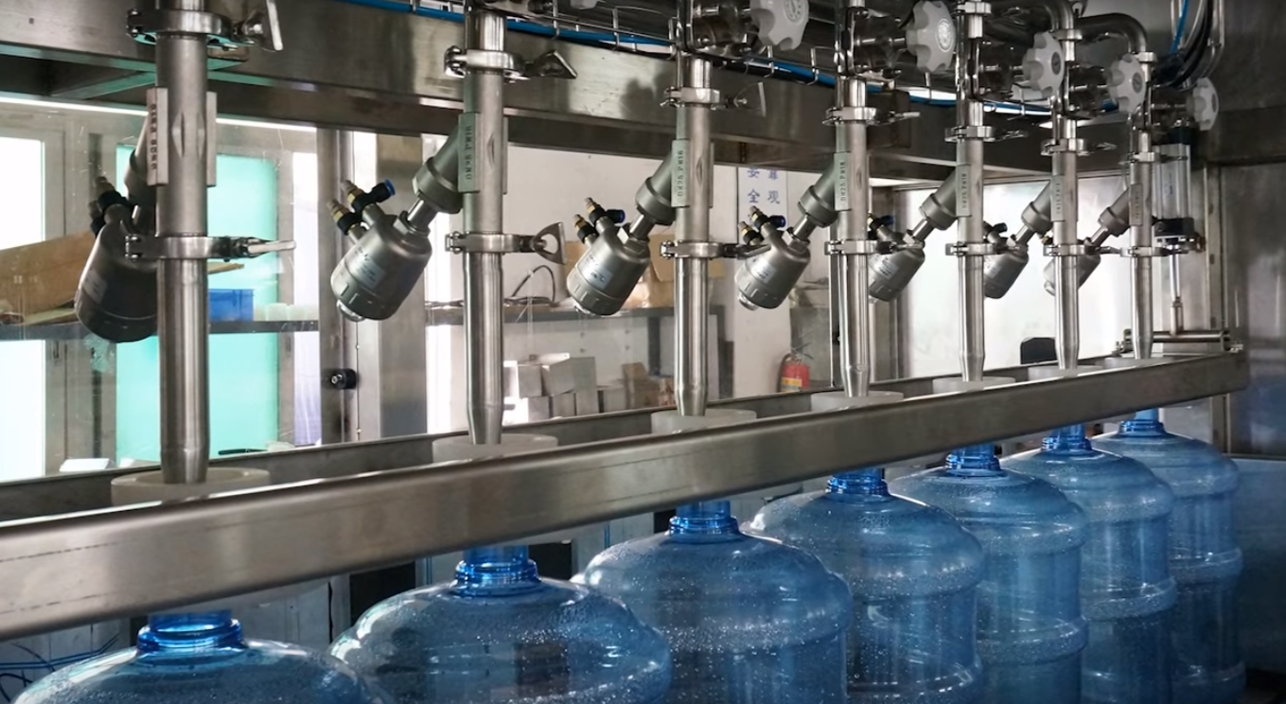

<https://www.youtube.com/watch?v=rBBmHEXHDN0>

|  |  |
| --- | --- |
| **7.6.Cap feeder & Cap washer** |  |

|  |  |  |  |
| --- | --- | --- | --- |
| **Model** | **Capacity(BPH)** | **Heads** | **Dimension(L*W*H)(MM)** |
| **SGL** | 2000 |  | 2000*700*2800 |

**Definition**

To send the caps from the cap container to the cap unscramble. By using the belt to the lift cap.

The caps are put into the cap feeder container manually, then it will be sent to the cap unscramble by the belt, on the top of the cap feeder, one set motor will drive the belt. After the cap is sent to the un-scrambler, the caps will be organized there and sent to the cap washer chute.

**Features:**

Reduce the working intensity of labor

With cap lack inspection and alarm device

**B. Cap washer**

cap washer is to wash the cap. A cap sorter is equipped to cap washer. Caps are first transferred to cap washer by cap feeder, and then be unscrambled through cap chute and enter in cap washing tunnel. After disinfectant liquid rinsing, ozone water rinsing, and drip processes in turn, cap are sterilized and cleaned, and then transferred to capper.

**Features:**

Cap un-scrambler is assembled by 3mm stainless steel 304, it is simple and adjustable, suitable for caps with tail.

● Built-in doors on the top of washing tunnel. Easy clean and maintenance.

●Open design cap chute, a variety of caps of different sizes are available.

● One set independent disinfectant tank is equipped for the disinfectant rinsing .

●Cap chute move cap forwards by high pressure water rinsing.

●Cap chute (connection bridge between cap washer to capper) made of 3 mm stainless steel 304. Strong, durable, guarantee stable performance.

●Cap chute is adjustable. It is able to adjust accurately according to cap size, guarantee cap passing smoothly, and effectively avoid cap jam.

●Cap chute is in a closed cabinet. Effectively avoid secondary contamination to cap.

●Equipped with windows, easy monitoring running status. Window made of 10mm thickness tempered glass.

● Built-in alarm device. Automatic alarm via sound and lamp if cap is absence.

* The cap washer machine will be installed on the top of the inner washer machine .

|  |  |
| --- | --- |
| **7.7.Capper** |  |

|  |  |  |  |
| --- | --- | --- | --- |
| **Model** | **Capacity(BPH)** | **Heads** | **Dimension(L*W*H)(MM)** |
| **XG-3000** | MAX 3000 |  | 2300*790*2300 |

**Definition**

Capper is to put cap onto bottle mouth, and seal cap. This capper adopts presser-belt sealing method.

**Features:**

●Stainless steel presser-belt.

●Adjustable height of presser-belt. It is able to adjust capping intensity accurately according to bottle height, and achieve tight sealing.

●Control by PLC and sensors. Automatic run synchronously as bottles enter capper. No bottle no working. Reduce energy consumption and extend lifetime of motor.

●It is built together with filler. Bottle is sealed with cap immediately after filling. Prevent contamination to water in the bottle.

●Water chute shaped on bottom plate. Water drained quickly.

|  |  |
| --- | --- |
| **7.8.Label applicator** |  |

**Definition**

To put the sleeve label to the capped bottle mouth automatically.

**Features:**

● Label length can be easily reset on the touch screen

● Single positioning center guider pillar, stable for label delivery

● Adjustable cutter header, unique cyclotron cut-off, double sided cutting edge with long service life.

● Servo system, accurate label-inserting.

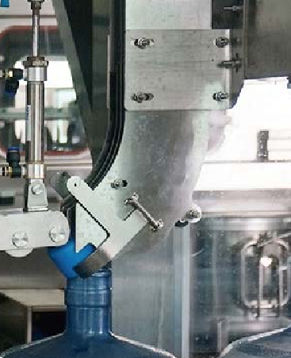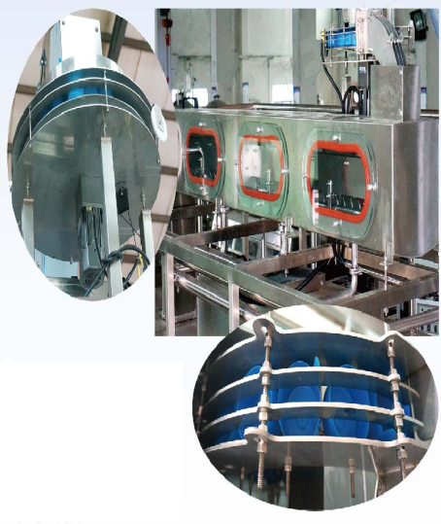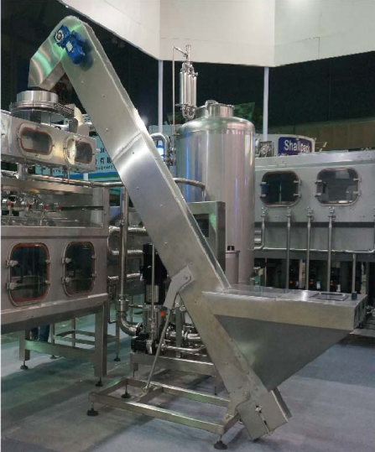

|  |  |
| --- | --- |
| **7.9.Shrinking oven** |  |

**Definition**

Shrinking oven is used to shrink the film on bottle mouth to assure the bottle sealed and anti-counterfeit.

**Features:**

● no need pre-heating , it can be used after one minute startup

●economical power consumption.

●No water consumption, avoid scale generating on heating tube, extend lifetime of heating tube.

● intelligent temperature control system ,adaptive to different material of file with different thermal contraction features .

|  |  |
| --- | --- |
| **7.10.Ligh inspector** |  |

|  |  |  |  |
| --- | --- | --- | --- |
| **Model** | **Capacity(BPH)** | **Type** | **Dimension(L*W*H)(MM)** |
| **LIR-03** |  | LED | 1280 |

**Definition**

Lighting box is used for bottled water quality inspection , by high light LED box, no twinkle , low power consumption

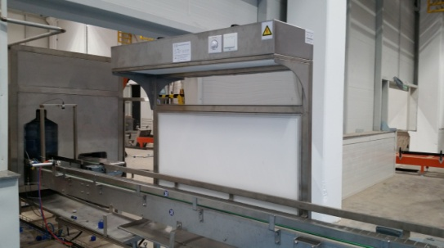

**Features**

● LED on front plate and bottom of top plate

● Low power and long life-time.

● Equipped with adjusting knob. Lighting intensity is adjustable.

● High quality LED light source, bright and soft light.

● No stroboscopic, stable color-temperature.

|  |  |
| --- | --- |
| **7.11. Controlling system** |  |

**Definition**

The whole production line is controlled through a central control cabinet. Each single machine runs automatically under the controlled of PLC which is built in central control cabinet.

**Features:**

●Famous brand components, ensure the system runs stable.

●SIEMENS PLC and touch screen, Schneider or ABB electronic components

**8. Preparing jobs from the customer’s side.**

8.1: Electricity cable extends to system’s control cabinet/box.(3 phase,5 cables, 380V, 50Hz) （If voltage and frequency is different, customer need to prepare the potential transformer and frequency changer）

8.2: Chemical material such as Detergent and disinfectant during machine commissioning process.

8.3 Construct waste water discharge tunnel or floor drain according to design requirement

8.4: Compressed air extends to the required points. Capacity: 3M3/min, pressure: 0.8Mpa.

8.5: To send 8pcs sample bottles and 200pcs sample caps for the machine fabricating and testing.

8.6: The inner washing pump/filling pump/cap washing pump is not provided by this proposal.

8.6: The inner washer machine tanks equipped the automatic water replenishing system, however, the water source and the pump is provided by the buyer, The water capacity 2-3M3/H with the pressure 0.3Mpa.

|  |  |
| --- | --- |
| **9. Price List** |  |

|  |  |  |  |  |  |
| --- | --- | --- | --- | --- | --- |
| No. | Item | Unit Price  (USD) | Quantity | Amount  (USD) | Remarks |
| 1 | De-capper | 7,400 | 1 set | 7,400 | De-capper head:4 ,Cylinder: Airtac |
| 2 | Outer washer | 19,620 | 1 set | 19,620 | Pump brand: GRUNDFOS, Motor: SITI  Rinsing stages:03(*), Model: WX-R-6  Linear type |
| 3 | Odour detector | 54,000 | 1 set | 54,000 | Liner type  Stage : 6 head  Motor :SITI . Cylinder : Airtac .Siemens PLC touch screen |
| 3 | High pressure washer | 135,000 | 1 set | 135,000 | Pump brand : UDOR Italy  Motor : SITI  Washing stage : 8  Cylinder :Airtac  Electronic components: Schneider brand  Siemens PLC and touch screen |
| 4 | Inner washer/filler/capper/cap feeder | 155,600 | 1 set | 155,600 | Output capacity: 2000BPH.  Rinsing nozzle: 10 rows Rinsing stages:16,  Pump: GRUNDFOS brand .11(*) Water tanks: 4 (*)  Filler heads: 10 heads, Multi row type filling  Capper: SS presser-belt. |
| 5 | Cap washer | 9,360 | 1 set | 9,360 |  |
| 6 | Label applicator | 18,000 | 1 set | 18,000 | By using the PVC label ,roller type |
| 7 | Shrinking machine | 4,522 | 1 set | 4,522 | High temperature air shrinking type |
| 8 | Central control cabinet | 14,500 | 1 set | 14,500 | Siemens PLC and touch screen  Electronic components: Schneider brand |
| 9 | Conveyor with belt | 530 | 40M | 21,200 | To connect each individual machine  *The actual amount will be recalculated as per the final layout .* |
| 10 | Roller conveyor | 450 | 8M | 4,640 | *The actual amount will be recalculated as per the final layout .* |
| 11 | Lighting box | 967 | 4sets | 3,868 | LED type |
| 12 | Automatic chemical  dosing system | 3,360 | 2 sets | 6,720 | One set for outer washer , two sets for detergent tanks of inner  washer. Prominent dosing pump , Germany brand  PE Tank , monitored by sensor |
| 1,800 | 2 sets | 3,600 | One set for the cap washing , one set for disinfectant tank of inner  Washer Prominent dosing pump , Germany brand  PE Tank , dosing by pre-set timing |
| 13 | Sanitary crossing ladder | 800 | 3 set | 2,400 | SS 304 material |
| 14 | Installation material | 7,800 | 1 unit | 7,800 | Including welding kits, wire and cable within bottling line,  piping system within bottling line, etc |
| 15 | Packing cost | 6,000 | 1unit | 6,000 | By wooden box. Non-ISPM15 standard, 150CBM, USD40.00/CBM |
| 16 | Installing subsidy | 4,200 | 1 unit | 4,200 | Needs 2 technicians, 30 days.  One engineer 10 days.  USD 60.00 per day per person |

**\*The actual total amount will be recalculated as per the final layout**

Pice in term : BMI – 4R Factory in Korea

Payment : 40% of the total amount is made via bank transfer as down payment and 60% of the balance is made before shipment of the goods

Loading time :120 days after down payment

The proposal will be in valid before 31th March 2018



**BMI-4R Co.,Ltd.**

**BMI-4R PACKAGING MACHINERY Ltd.**

**<Korea office&factory Address>**

79, Sicheong-ro 677beon-gil, Yuram-ri, Paltan-myeon,Hwaseong-si, Gyeonggi-do,Korea 18524

Tel : +82-31-366-4735

**<China factory Address>**

Building 21,Shichong minying industrial park,Hengli Town,Dongguan

city,Guangdong Province,China

Email : bmikorea@bottlewasher.kr

website : www.bottlewasher.kr